Gameactivity:   
table use this one. In file 50款扑克麻将斗地主游戏牌桌PNG素材1.psd

Line 2, col 3 ,mayram please prepare it for ali

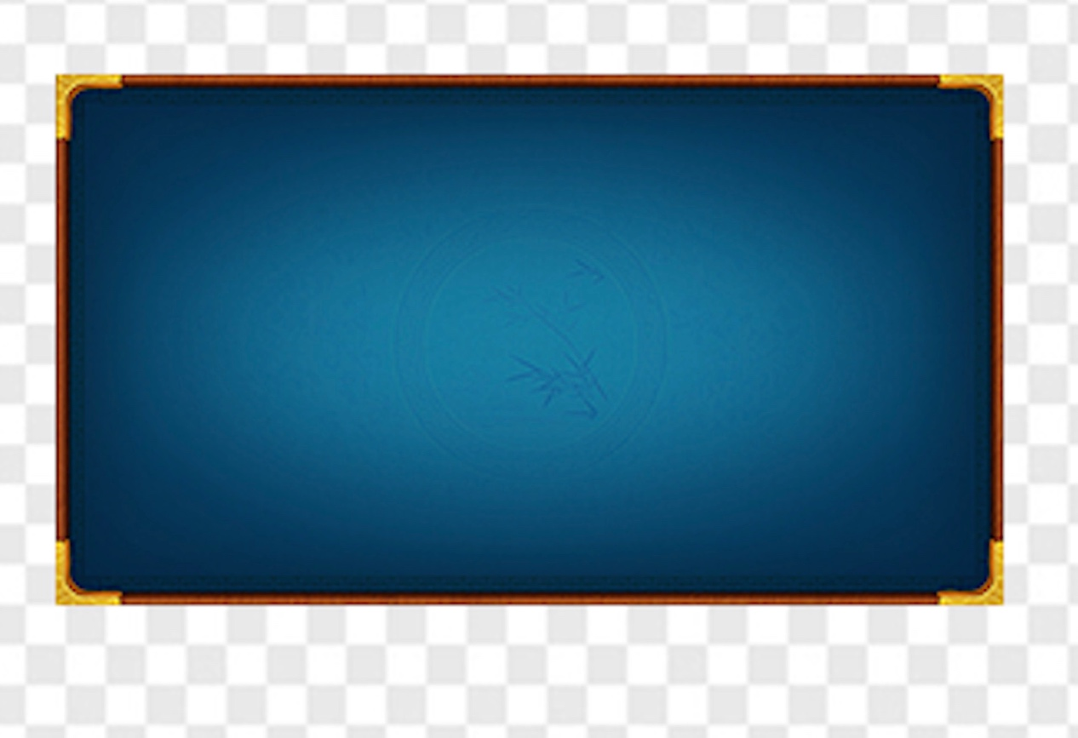

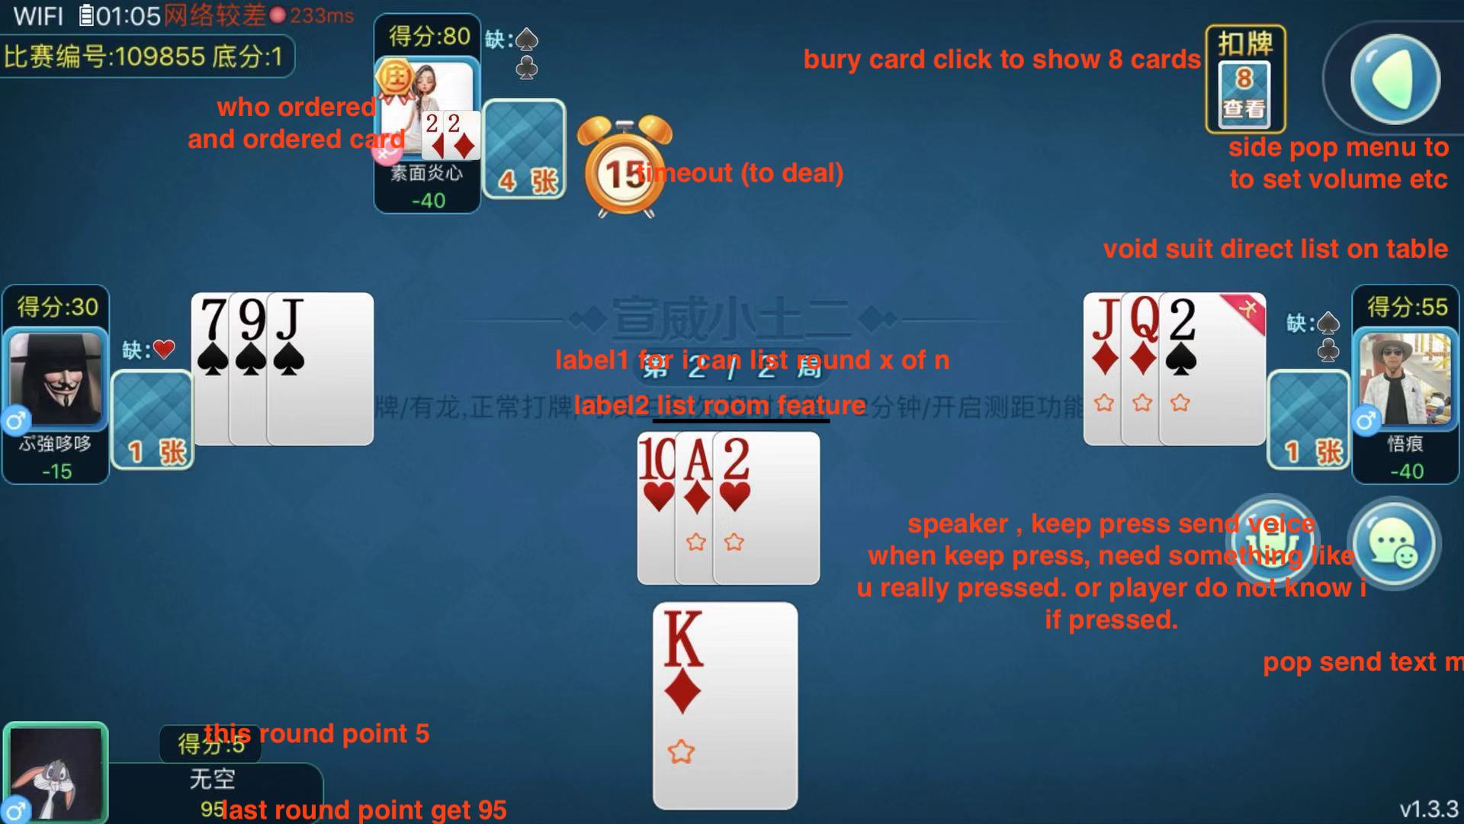

the ordered card can be 2 shape then fine. No need the number 2. (like the void suit. Only shape  
  
card size: 1. My card. Biggest  
2.dealed card: middle  
3. Bury card (click to show 8 ) smallest

\*\*\*\* prepare something I can do some of my cards not selectable (such as grey)

login

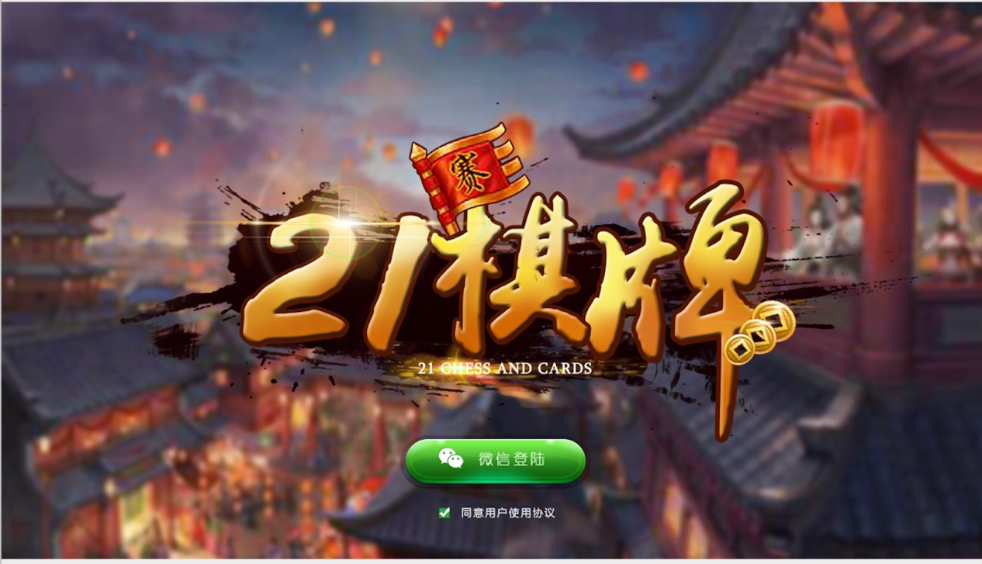

21棋牌 change to like this. (the background use the game center one. )  
土2棋牌

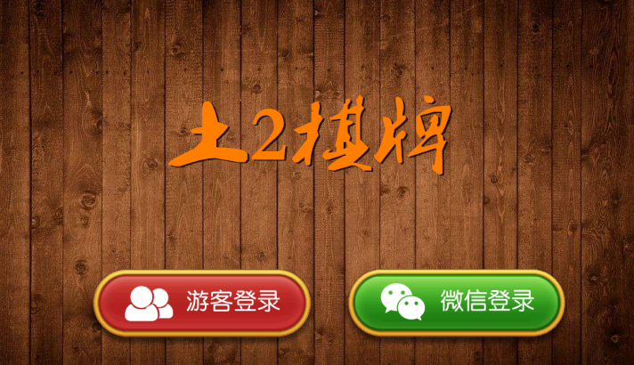  
add one more button   
游客登录

Game center.

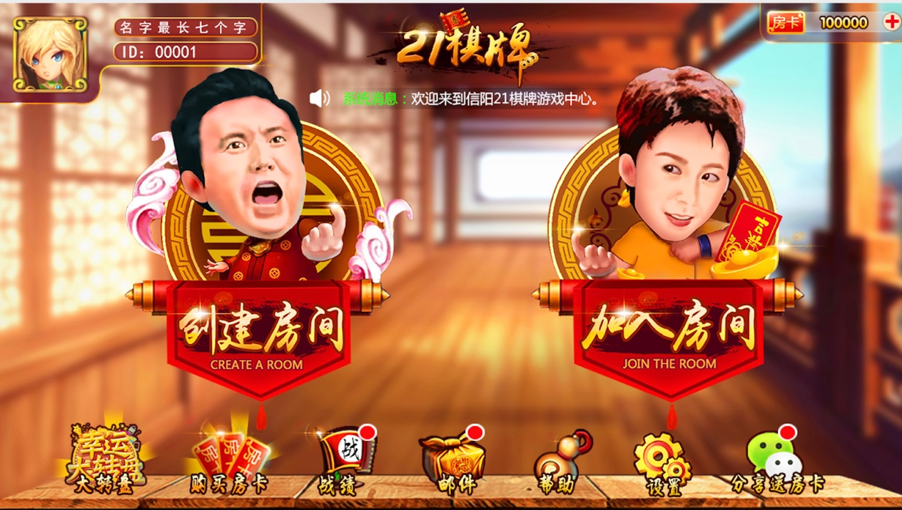

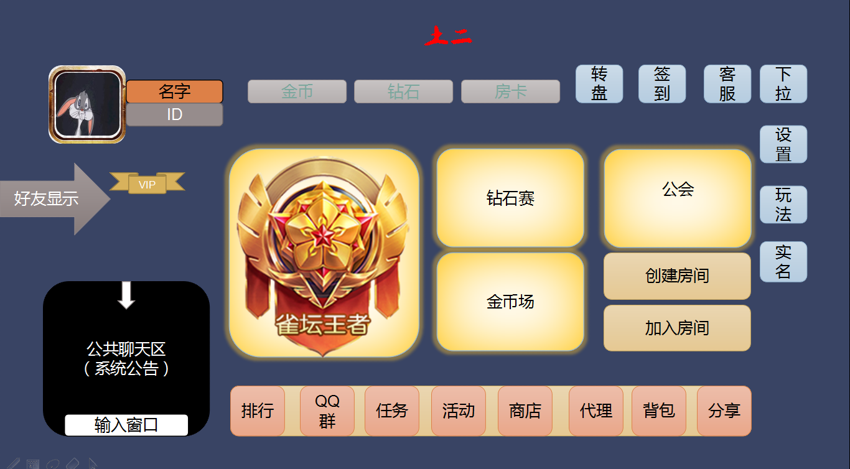

look his design

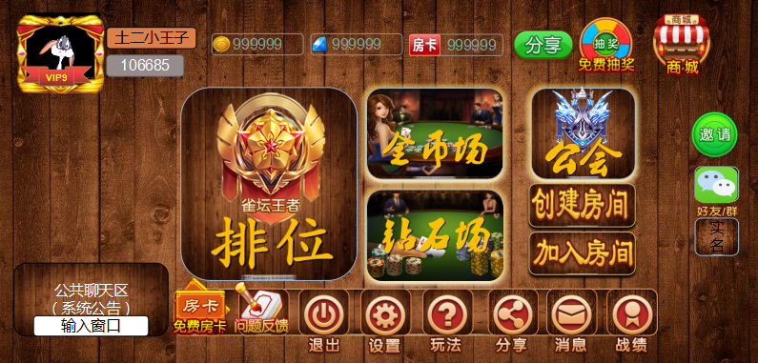

with this background add our button to see.

And the layout will change to.

(most use current we have icon, put it let me take a look)

小土二

金币 钻石房卡

转盘(wheel) 签到 客服 设置(setting)

段位场 (will show stamp,later I will list) (room type 1)  
钻石赛 (room type 2)  
金币场 (room type 3)  
sign=== 公会  
创建房间（create room）  
加入房间(join room)

排行 (top 10)

任务 （task） 活动(this no need) 商店(shop) 代理(agent apply) 背包(my tools) 分享(share)

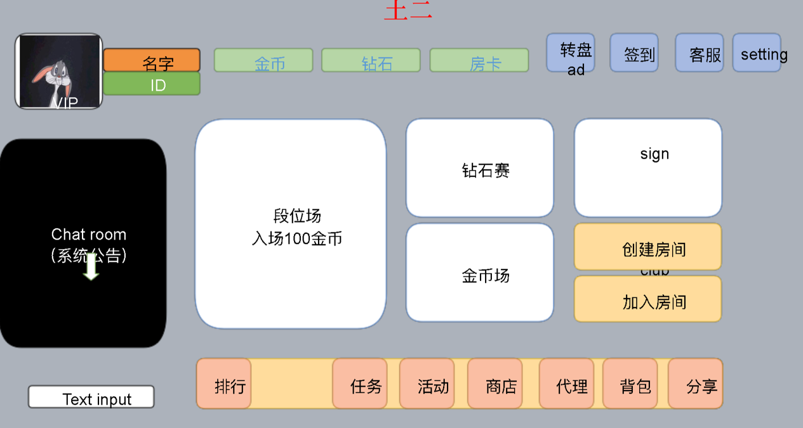

Stamp

File stamp.psd

We need 7 stamp.

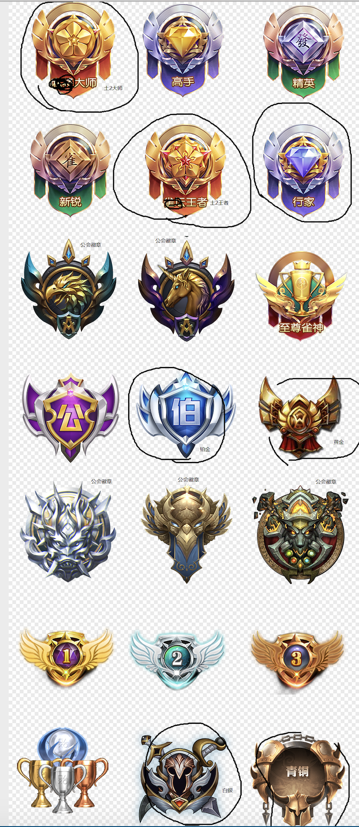

土2大师

土2王者

we use this 7 stamp only